CBOE Direct
System Health Monitor
Phase 3
Feature List

Prepared By:
Troy Wehrle

Version: 2.5
Last Saved: 7/14/2004 07:22:00 PM

Feature Priority Matrix 4
Inter-Process Instrumentation Collector – Alarm Conditions 5
Current Situation 5
Proposed Solution 5
Instrumentation Alarms 5
Process Watcher Alarms 5
Alarm Scope – Global 5
Alarm Scope – Local 5
Connected Mode – Configuration 5
Current Situation 5
Proposed Solution 6
ICS Admin Commands 6
Current Situation 6
Proposed Solution 6
Improved Heartbeating 6
Current Situation 6
Proposed Solution 6
Infrastructure Improvements to Archiver 6
Current Situation 6
Proposed Solution 6
Dynamic Definition of Environment to Operate GUI with 7
Current Situation 7
Proposed Solution 7
Dynamic Definition of SACAS to use for Product Query Lookup 7
Current Situation 7
Proposed Solution 7
Re-Initializing of Product Query Lookup References 7
Current Situation 7
Proposed Solution 7
Provide Product Lookup Interface 8
Proposed Enhancement 8
Re-Layout the System Summary Screen 8
Current Situation 8
Proposed Solution 9
Add “Find Next” Functionality to the Search Feature 9
Current Situation 9
Proposed Solution 9
Provide Extended Navigation from System Summary to Matching Alarm Entry 9
Proposed Enhancement 9
Provide Ability to Filter System Summary Status 9
Current Situation 9
Proposed Solution 10
Provide More Detailed Process States 10
Current Situation 10
Proposed Solution 10
Add System Health Attributes to Process Information 10
Current Situation 10
Proposed Solution 10
Improve Implementation for Storing Preference Files 10
Current Situation 10
Proposed Solution 10
Provide Individual User Preference Settings 11
Current Situation 11
Proposed Solution 11
DDTS Entries 11
CBOqa06090 - Tree Expansion is lost on non-visible tabs 11
CBOqa06038 - Duplicate Class showing in Context Detail 11
CBOqa06227 - Allow exclusion and multiple filters in SHM 11
CBOqa06309 - SHM - CAS Monitor screen - NPE on sorting version 11
CBOqa06381 - Log CASMon table data to file 11
CBOqa06430 - SHM Subscription Counting Seems to be Wrong 12
CBOqa06424 - Check Sorting on all Columns in CAS Mon Screen 12
Cancel Orders 12
Select Orders for Cancellation 12
Provide Query to Find All Cancelled Orders 13
Cancel Quotes from SA GUI 13
Cancel Event Logging Enhancements 14
Revision History 15

Feature Priority Matrix
Feature | Priority | Time Estimate (Days)
Connected Mode – Configuration | 2 | ICS-8
Instrumentation Alarms & Alarm Scope – Global | 3 | G-15; ICS-15
CBOqa06090 - Tree Expansion is lost on non-visible tabs | 5 | G-5
Dynamic Definition of Environment to Operate GUI with | 6 | G-5
Provide Ability to Filter System Summary Status | 7 | G-5
Add “Find Next” Functionality to the Search Feature | 10 | G-5
Process Watcher Alarms | 99 | G-14; ICS-14
Alarm Scope – Local | 99 | G-14; ICS-14
Cancel Orders - Select Orders for Cancellation | 99 | S-30; C-5; G-10
Cancel Orders - Cancel Quotes from SA GUI | 99
Cancel Orders - Cancel Event Logging Enhancements | 99
Dynamic Definition of SACAS to use for Product Query Lookup | 99 | G-3
Re-Initializing of Product Query Lookup References | 99 | G-3
Provide Product Lookup Interface | 99 | G-1
Re-Layout the System Summary Screen | 99 | G-5
Provide Extended Navigation from System Summary to Matching Alarm Entry | 99 | G-3
Provide More Detailed Process States | 99 | G-5; C-15
ICS Admin Commands | 99
Improved Heartbeating | 99
Infrastructure Improvements to Archiver | 99
Add System Health Attributes to Process Information | 99 | G-5
Improve Implementation for Storing Preference Files | 99 | G-3
Provide Individual User Preference Settings | 99 | G-5
CBOqa06430 - SHM Subscription Counting Seems to be Wrong | 99
CBOqa06424 - Check Sorting on all Columns in CAS Mon Screen | 99
CBOqa06038 - Duplicate Class showing in Context Detail | 99 | G-1
Cancel Orders - Provide Query to Find All Cancelled Orders | 99 | G-?; C-5; S-?
CBOqa06227 - Allow exclusion and multiple filters in SHM | 99 | G-
CBOqa06309 - SHM - CAS Monitor screen - NPE on sorting version | 99 | G-
CBOqa06381 - Log CASMon table data to file | 99
G = GUI Resources; S = Server Resources; C = CAS Resources; I = Infra Resources

Inter-Process Instrumentation Collector – Alarm Conditions

Current Situation
Currently the System Health Monitor GUI only displays the Instrumentor data that our CBOE Direct system has available. For a person to determine if there is a problem, they must examine all the data, including one elements data in relationship to another elements data. There is too much data for any one person to continually examine and this does not provide us the early warning we would prefer.

Proposed Solution
The GUI will be able to setup different alarm conditions on this new program. These alarm conditions may reflect values of particular data or relationships across values of multiple particular data. If during the course of processing the Instrumentation data within this new program, an alarm condition is satisfied, an alarm event can be sent to the GUI. This will enable the GUI to better highlight true alarm conditions that are considered significant to the users.

Instrumentation Alarms
The Alarms functionality would be implemented for the Instrumentation data, in this stage. These include ORB Name (All, or specific ORB Name), Context Name (All, or specific Context Name), Instrumentor Type, Instrumentor Field.

Process Watcher Alarms
The Alarms functionality would be implemented for the Process Watcher data, in this stage. These include ORB Name (must be specific ORB Name) & Process State (Up, Down, Master, Slave).

Alarm Scope – Global
Global alarms activation should go to all System Health GUIs and should live past the life of the GUI.

Alarm Scope – Local
Local alarm activations should be only sent to the System Health GUI that asks for them. Local alarm activations should be removed when the GUI is shutdown.

Connected Mode – Configuration

Current Situation
The initial version of the Instrumentation Collector Server (ICS) was written without the full Infrastructure/Central Rep resources. It cannot be centrally configured and cannot be started utilizing the Foundation Framework. We are only to start it using a custom start script.

Proposed Solution
The ICS should be configured so that it is launched using the Foundation Framework. It should get its configuration from the SysManAgent and the CentralRep in connected mode.

ICS Admin Commands

Current Situation
The ICS does not have a way to dynamically configure its logging properties. It would also be nice if we could re-initialize the state of the ICS without causing all the connected GUI’s to restart.

Proposed Solution
We propose adding an Admin Commands interface to the ICS so that these things can be addressed. The logging properties would then be able to be dynamically configured. We could also force the ICS to cleanup user sessions, republish all data to everyone connected, cause it to internally restart, stop publishing alarm notifications (still process and log the alarms) and stop all alarm notification processing (no central logging).

Improved Heartbeating

Current Situation
The initial version of the ICS watches for connected GUI’s to disappear by utilizing Process Watcher. This requires all connected GUI’s to be listed in the PW watch list. This is not very flexible for GUI installations. We use this information to allow the ICS to cleanup its session information and caches for a particular GUI.

Proposed Solution
We would like to have a way to allow the ICS to heartbeat back to the GUI’s for final determination when the GUI’s disappear.

Infrastructure Improvements to Archiver

Current Situation
The Infrastructure Archiver is not currently archiving the CAS’es queue instrumentors. It also seems to have a problem properly writing out the user data that is imbedded in the instrumentors

Proposed Solution
We would like Infrastructure to correct these problems in the Archiver.

Dynamic Definition of Environment to Operate GUI with

Current Situation
The existing GUI must be configured for an environment by hand editing the appropriate batch executable file and properties file. This needs to be done for each attempt to run the GUI in a new or changed environment.

Proposed Solution
We propose to allow selection of environments from within the GUI prior to the launching of the GUI. The user will be provided with a choice of environments to select from, and once selected, the GUI will operate with that environment.

Dynamic Definition of SACAS to use for Product Query Lookup

Current Situation
The Instrumentation data contains only class and product keys. We use a specific SACAS to resolve these keys to actual classes and products. This allows us to show more detail about the classes and products to the user. Currently, the user must hand edit a properties file to specify which SACAS they would like to use. We do not have a way for the user to specify this within the GUI interface itself.

Proposed Solution
We propose providing a selection screen so that the user can select from a choice of SACAS’es to use for resolving the class and product keys. This will allow our application to continue to work at its optimum if the original SACAS becomes absent.

Re-Initializing of Product Query Lookup References

Current Situation
Currently, if we fail in trying to resolve the class and product keys information in the Instrumentation data from the SACAS, we will consider the SACAS absent and not try again.

Proposed Solution
We propose providing a screen component to allow the user to gesture that they would like our application to refresh its state of the SACAS and try again to resolve class and product keys with it. This will allow our application to continue to work at its optimum if the original SACAS became absent for some reason previously, but has since been restored.

Provide Product Lookup Interface

Proposed Enhancement
Include the existing Product Query Lookup dialog from our other applications in this application. This will allow a user who has only a product or class key to perform a query to display all relevant detailed information for those products or classes.

Re-Layout the System Summary Screen

Current Situation
The System Summary screen is limited to how many processes can be displayed at one time due to the layout of the screen.
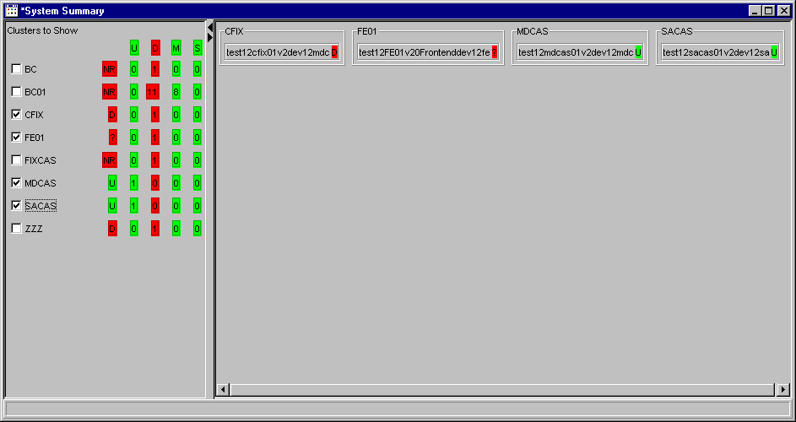

Proposed Solution
We propose changing the layout to provide a more compact display so that more processes can be displayed at one time on the screen.
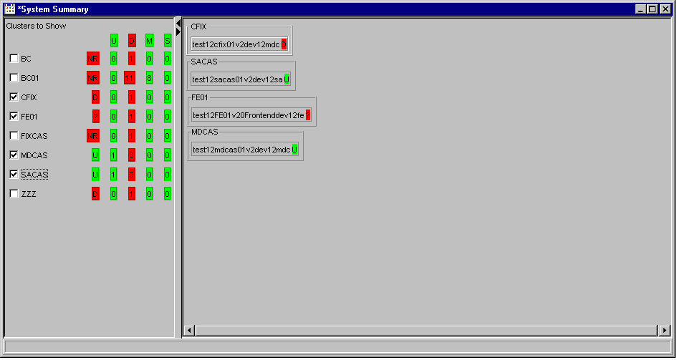

Add “Find Next” Functionality to the Search Feature

Current Situation
The search functionality available in the navigation tree is limited to finding the first search match. You cannot continue from there.

Proposed Solution
We propose adding some “Find Next” functionality to this search feature.

Provide Extended Navigation from System Summary to Matching Alarm Entry

Proposed Enhancement
When a summary process is selected in the tree navigation, clicking on one of the filtering options should scroll to view and select the first process that resulted in that matching the filtering option. While that item is selected, clicking on the filtering option again should scroll to view and select the next one.

Provide Ability to Filter System Summary Status

Current Situation
The System Summary screen does not provide any functionality to filter out certain data.

Proposed Solution
Provide the same filtering functionality (Up, Down, etc.) to the System Summary screen. The user would also like to filter out certain ORB and/or group names.

Provide More Detailed Process States

Current Situation
Currently the Process Watcher only keeps track of Up and Down states for a given process. When a processes state changes to Up, it is not an indication that the process is initialized and ready for business. It only indicates that the process does indeed exist as an OS live process. This state generally changes to Up, minutes before a process is actually finished initializing and ready for business. This can cause timing issues with trying to communicate with a given process based on the change of Process Watcher status.

Proposed Solution
We propose added a new state identifying the Ready/Initialized stage. This would have to be supported by Process Watcher and each process would need modified to set it appropriately.

Add System Health Attributes to Process Information

Current Situation
Currently the highlights for specific data alarm points are fixed colors and based on pre-determined, fixed values.

Proposed Solution
A proposal has been made to allow the user to designate the colors and/or patterns and threshold values to be set per individual process. These could be tied to the ORB aliases that we are allowing the user to set, as well as the users custom groupings.

Improve Implementation for Storing Preference Files

Current Situation
The preference files are stored in a common location for all instances of the application to use. The current implementation cannot handle the creation of remote directories.

Proposed Solution
Extend the implementation to be able to create remote directories. This will facilitate the implementation of Individual User Preferences.

Provide Individual User Preference Settings

Current Situation
The preference files are stored in a common location for all instances of the application to use. The current implementation allows only one master GUI application to setup the preferences as desired. Every other GUI installation then reads this common preferences file and uses the same settings. This does not allow each user to have their own settings for ORB aliases and groupings, colors and/or patterning, threshold values for alarms, etc.

Proposed Solution
Allow a user to specify a profile of settings they would like to use. They may also create a new profile to save settings within. This would not require any specific login. The specification of a profile would be totally voluntary. We would save the settings in a specific file designated for that profile.

DDTS Entries

CBOqa06090 - Tree Expansion is lost on non-visible tabs
Sometimes the tree expansion on the non-visible tabs is lost. If you expand the tree on the System Health screen, then go to a different tab, then go back to the original tab, sometimes the tree expansion is lost.

CBOqa06038 - Duplicate Class showing in Context Detail
The Context Detail Classes section of the screen shows a session product class as both a session product class and a product class. For example the class "W_MAIN IBM (Option)" would show as both "W_MAIN IBM (Option)" and "IBM (Option)".

CBOqa06227 - Allow exclusion and multiple filters in SHM
Filters on the System Health and CAS Monitor screens would greatly enhance the operator usability of the GUI. Currently only single inclusion filters by cluster are allowed. Multiple inclusion and exclusion filters of clusters would greatly enhance the ability to determine problems and place the burden on the SHM instead of the user. CBOqa06224 also would benefit from this enhancement.

CBOqa06309 - SHM - CAS Monitor screen - NPE on sorting version
When sorting on the Version Column i CAS Mon it will occasionally sort - but often it will not. I check the console window and saw the following:
"java.lang.NullPointerException"

CBOqa06381 - Log CASMon table data to file
So that the SHM's CASMon can be used for historical queries, it would be helpful to log to file every X (configurable) seconds the data in the CASMon's table.

CBOqa06430 - SHM Subscription Counting Seems to be Wrong
OPS was using prdcons8 and adding many subscriptions, then got the exceeded subscriptions message. OPS then unsubscribed for a few of the lower priority items, but still got the limit-exceeded problem. Next they removed all subs but still got the error when adding a new sub.

CBOqa06424 - Check Sorting on all Columns in CAS Mon Screen
The Version column does not sort, it throws a NPE, probably due to CAS’es that are not UP. Other columns seem to show 0 or empty string so they sort fine. During the testing of this specific DDTS, the entire table's columns need to be tested for correct setting with some CAS’es that are DOWN.

Cancel Orders

Select Orders for Cancellation
Currently, to display order status, the CBOE Help Desk selects “Orders” from the SA GUI User Management function. This causes the Orders tab to display. From this window, the CBOE Help Desk is able to view the status of orders for a particular user.

Users can be selected by CBOEDirect User ID, by Name or by Exchange/Acronym. Once a user is selected, the Help Desk must specify the product type, product class and product (contract month) from drop down list boxes. Currently, the list of orders for the selection criteria is displayed.

To enable the Help Desk to quickly locate orders that must be canceled, the Help Desk SA GUI and the CBOEDirect server will be enhanced to allow a Help Desk user to submit a cancel request to cancel all orders that match the selection criteria. In addition to searching order status by User, the following searches will be supported, irrespective of user:

- Session (All is not allowed)
- Executing/Give-Up Firm
- Time-in-Force
- Class
- Product
- Trade Server

The Help Desk should be able to select “All” for Product Class, Product and Product Type. The Help Desk should also be able to select Orders by Time in Force: by all, by GTC, etc. The Help Desk should be able to combine search criteria. Queries may not be made across session.

This new enhancement will display a summary of the orders to cancel. The Help Desk will be able to send a request to the server to cancel all orders that meet the selection criteria. Prior to the server executing the cancel request, the GUI will display an “Are you sure?” dialogue box that includes a list of the search criteria that will be canceled. The Help Desk will have the option to confirm the cancel request or cancel the action.

Both the Help Desk and the actual user should receive acknowledgements that the cancel request was successful. It is assumed that the Help Desk will utilize the Market Replay application to obtain historical documentation of canceled orders.

Current functionality to display user orders by product type, product class and product will remain available to the Help Desk.

It is assumed that I-orders will be handled as orders, not quotes, when selecting criteria for cancellation. If an I-order matches the search criteria, it will be canceled.

Provide Query to Find All Cancelled Orders
Investigate a way to query for all the Orders that were cancelled by the above feature.

Cancel Quotes from SA GUI
Currently, if a market maker is having systems issues, the Help Desk cancels their quotes by forcing a user log-off. The log-off triggers quote cancellation. Logging off affected users in order to cancel quotes is having a negative impact on market making firms including Timber Hill, Susquehanna and Citadel. Logging off an individual user requires these firms to log off additional users. To address this issue, the CBOE Help Desk requests a function that will allow them to cancel quotes.

To enable the Help Desk to quickly locate quotes that must be canceled, the Help Desk SA GUI and the CBOEDirect server should allow a Help Desk user to submit a cancel request to cancel all quotes that match the selection criteria. The following searches should be supported:

- Session
- Class
- Product
- Product Type
- Trade Server

The Help Desk should be able to select “all” for Product Class, Product and Product Type. This enhancement will not display the quotes to cancel. The Help Desk will be able to send a request to the server to cancel all quotes that meet the selection criteria. Prior to the server executing the request, the GUI will display an “are you sure” dialogue box that includes a list of the search criteria that will be canceled. The Help Desk will have the option to confirm or cancel the action. Both the Help Desk and the actual user should receive acknowledgements that the cancel request was successful.

Cancel Event Logging Enhancements
The CME provides its users with a special identifier for orders canceled by the Globex Control Center. CME has asked OneChicago to support similar functionality when the CBOE Help Desk cancels its users orders. When the CBOE Help Desk cancels orders generated by the CME Globex Gateway, Help Desk should appear in the User Assigned Cancel ID field.

All Help Desk cancel activity must be electronically logged. Note: Implementation of this change must be coordinated with the CME.

Revision History
1.0 Original Version containing Revision History.
1.1 Removed DDTS CBOqa06176
Split Inter-Process Instrumentation Collector into two tasks on the Feature Priority Matrix.
Added time estimates.
Adjusted priorities and sorted Feature Priority Matrix.
1.2 Added new/changed Cancel Orders Requirements.
Split Cancel Orders into multiple tasks on the Feature Priority Matrix.
Revised estimate for Cancel Orders task due to addition of requirements.
1.3 Modified aspects of Cancel Orders Requirements.
Added new Cancel Orders Feature.
Revised estimates for Cancel Orders tasks due to further requirements discussion.
1.4 Added new DDTS entries. Added them to the priority matrix as well.
Adjusted priorities and sorted Feature Priority Matrix based on email feedback dated 5/4/04.
1.5 Modified aspects of Cancel Orders Requirements.
1.6 Removed all SAGUI Enhancements and ACL GUI. They have been listed as enhancements in DDTS.
2.0 Removed the items completed in the first iteration.
Re-prioritized latest items.
Added new DDTS’es.
2.1 Added Connected Mode, ICS Admin Commands, Improved Heartbeating and Infrastructure Improvements to Archiver features.
Re-prioritized features based on Sprint # 2 Kickoff.
2.2 Changed priorities to raise CBOqa06354.
2.5 Removed the items completed during the first & second iteration.
Split up alarms feature into multiple parts.
Added new DDTS’es.

